MY SQL PROJECT
SCHOOL MANAGEMENT SYSTEM

Theme:
A school wants to maintain student details, subjects, exams, and students’ scores for each subject and exam.

Modules:
- Students
- Subjects
- Exams
- Marks

ER Diagram:
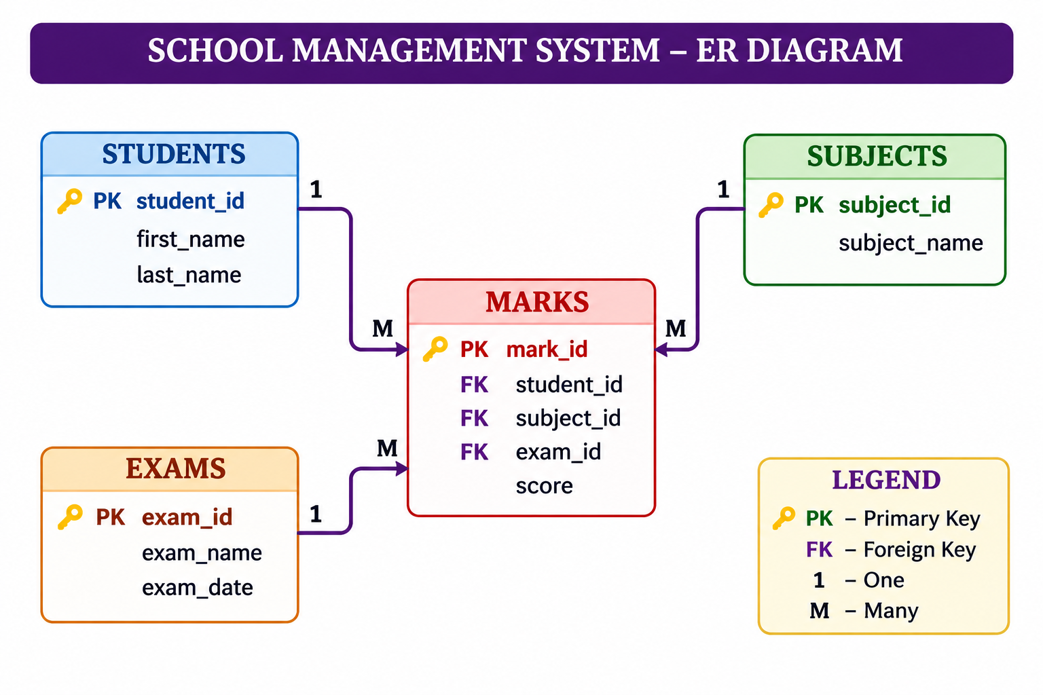

CREATING DATABASE:
Create database school_managment;
Use school_managment;

CREATING TABLES:

1. Students:
create table students (
student_id int primary key,
first_name varchar(50) not null,
last_name varchar(50) not null);

2. Subjects:
create table subjects (
subject_id int primary key,
subject_name varchar(100) not null);

3. Exams:
create table exams (
exam_id int primary key,
exam_name varchar(100) not null,
exam_date date);

4. Marks:
create table marks (
mark_id int primary key,
student_id int not null,
subject_id int not null,
exam_id int not null,
score int);
alter table marks
add foreign key (student_id) references students(student_id);
alter table marks
add foreign key (subject_id) references subjects(subject_id);
alter table marks
add foreign key (exam_id) references exams(exam_id);

Insertion:
insert into students (student_id, first_name, last_name)
values
(1, 'Aarav', 'Sharma'),
(2, 'Diya', 'Reddy'),
(3, 'Rahul', 'Kumar'),
(4, 'Priya', 'Verma'),
(5, 'Arjun', 'Rao');
insert into subjects (subject_id, subject_name)
values
(1, 'Mathematics'),
(2, 'Science'),
(3, 'Hindi'),
(4, 'English');
insert into exams (exam_id, exam_name, exam_date)
values
(1, 'Half-Yearly 2024', '2024-09-15'),
(2, 'Final Exam 2025', '2025-03-20'),
(3, 'Unit Test 2025', '2025-06-10');
insert into marks (mark_id, student_id, subject_id, exam_id, score)
values
(1, 1, 1, 1, 92),
(2, 1, 2, 1, 85),
(3, 1, 3, 1, 68),
(4, 2, 1, 1, 76),
(5, 2, 2, 1, 88),
(6, 2, 3, 2, 91),
(7, 3, 1, 1, 65),
(8, 3, 2, 2, 72),
(9, 3, 3, 2, 81),
(10, 4, 1, 2, 95),
(11, 4, 2, 2, 67),
(12, 4, 3, 3, 78),
(13, 5, 1, 3, 84),
(14, 5, 2, 3, 90),
(15, 5, 4, 3, 73),
(16, 1, 4, 2, 89),
(17, 2, 4, 2, 62),
(18, 3, 4, 3, 87),
(19, 4, 4, 3, 93),
(20, 5, 3, 1, 70);

Data:

STUDENTS:
Student ID | First Name | Last Name
1 | Aarav | Sharma
2 | Diya | Reddy
3 | Rahul | Kumar
4 | Priya | Verma
5 | Arjun | Rao

SUBJECTS:
Subject ID | Subject Name
1 | Mathematics
2 | Science
3 | Hindi
4 | English

EXAMS:
Exam ID | Exam Name | Exam Date
1 | Half-Yearly 2024 | 2024-09-15
2 | Final Exam 2025 | 2025-03-20
3 | Unit Test 2025 | 2025-06-10

MARKS:
Mark ID | Student ID | Subject ID | Exam ID | Score
1 | 1 | 1 | 1 | 92
2 | 1 | 2 | 1 | 85
3 | 1 | 3 | 1 | 68
4 | 2 | 1 | 1 | 76
5 | 2 | 2 | 1 | 88
6 | 2 | 3 | 2 | 91
7 | 3 | 1 | 1 | 65
8 | 3 | 2 | 2 | 72
9 | 3 | 3 | 2 | 81
10 | 4 | 1 | 2 | 95
11 | 4 | 2 | 2 | 67
12 | 4 | 3 | 3 | 78
13 | 5 | 1 | 3 | 84
14 | 5 | 2 | 3 | 90
15 | 5 | 4 | 3 | 73
16 | 1 | 4 | 2 | 89
17 | 2 | 4 | 2 | 62
18 | 3 | 4 | 3 | 87
19 | 4 | 4 | 3 | 93
20 | 5 | 3 | 1 | 70

Queries:
Level 1: Simple (Basic Selection & Filtering):
1. Retrieve all students: List the first name and last name of every student.
select first_name, last_name
from students;
Output:

#2:Filter by Score: Find all entries in the Marks table where the score is greater than 80.
select *
from marks
where score > 80;
output:
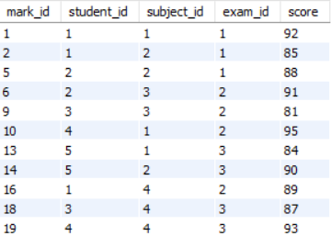

#3:Sort Data: List all exams sorted by their date, starting with the most recent.
select *
from exams
order by exam_date desc;
output:
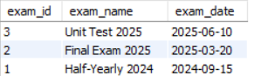

##Level 2: Intermediate (Joins & Aggregation)
#4:Student Marks: List the First Name, Subject Name, and Score for every mark recorded.
select students.first_name, subjects.subject_name, marks.score
from marks
join students
on marks.student_id = students.student_id
join subjects
on marks.subject_id = subjects.subject_id;
output:
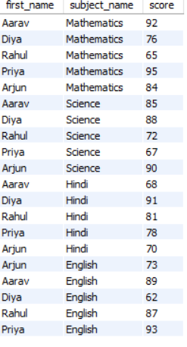

#5:Subject Averages: Calculate the average score for each subject. Display the Subject Name and the Average Score.
select subjects.subject_name, avg(marks.score) as average_score
from marks
join subjects
on marks.subject_id = subjects.subject_id
group by subjects.subject_id, subjects.subject_name;
output:
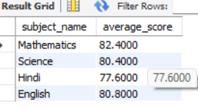

#6:Count Exams: How many marks have been recorded specifically for "Aarav Sharma"?
select count(*) as total_marks
from marks
join students
on marks.student_id = students.student_id
where students.first_name = 'Aarav'
and students.last_name = 'Sharma';
output:


##Level 3: Complex (Subqueries, Grouping & Logic)
#7:Top Performer: Find the student (First Name, Last Name) who has the highest single score in any exam.
select students.first_name, students.last_name
from marks
join students
on marks.student_id = students.student_id
where marks.score = (
select max(score)
from marks);
output:
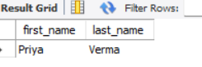

#8:Scores by Exam: Display the Exam Name and the total sum of scores for that exam, but only for exams where the total sum is greater than 250.
select exams.exam_name, sum(marks.score) as total_score
from marks
join exams
on marks.exam_id = exams.exam_id
group by exams.exam_id, exams.exam_name
having sum(marks.score) > 250;
output:
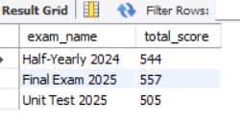

#9:Pass/Fail Label: Create a report showing the Student Name, Subject, Score, and a status column that says "Pass" if the score is 70 or above, and "Fail" if below.
select
students.first_name,students.last_name,subjects.subject_name,marks.score,
'Pass' as status
from marks
join students on marks.student_id = students.student_id
join subjects on marks.subject_id = subjects.subject_id
where marks.score >= 70
union all
select students.first_name, students.last_name, subjects.subject_name, marks.score,
'Fail' as status
from marks
join students on marks.student_id = students.student_id
join subjects on marks.subject_id = subjects.subject_id
where marks.score < 70;
output:

